Optical Networks

Homework IV

Survivability and Traffic Grooming

Ph. D. Ayşegül Yayımlı

Beycan Kahraman
504071508

Optical Networks  Ph. D. Ayşegül Yayımlı | Beycan Kahraman  504071508
Homework 4 | 12.12.2007

1. What are the differences between protection and restoration?

Protection is a scheme where backup resources (routes and wavelengths) are pre-computed and reserved in advance. However, if another route and a free wavelength have to be discovered dynamically when a failure occurs, this model is restoration scheme.

Generally, dynamic restoration schemes are more efficient in utilizing network capacity because they do not allocate spare capacity in advance, and they provide stability against different kinds of failures (including multiple ones). However, protection schemes have faster recovery time, and they guarantee recovery from broken services they are designed to protect against. In fact, restoration schemes can not guarantee recovery in failures.

2. Explain the different protection schemes, with your own example drawing: 1+1, 1:1, M:N.
1+1 Protection: Traffic is transmitted simultaneously on both primary and backup paths; therefore, the destination simply selects one of the two signals for reception. If one path is cut, the destination switches over to the other path and continues to receive the data. There will not be needed any signaling protocol between source and destination in this protection type. In addition, it is very fast in recovery.
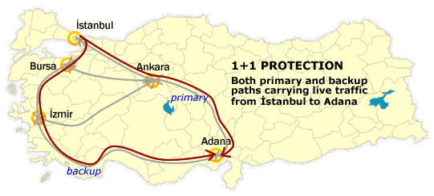

1:1 Protection: The traffic is only transmitted on the primary path. As a difference from 1+1 protection, the backup path is used for low-priority preferred traffic during normal operation, also it could be free when the primary one is operating.
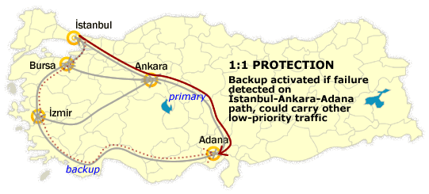

M:N Protection: It is expensive to create backup paths for each primary paths. Therefore, we may choose to use shared protection paths. In this case, M primary paths share N backup paths.
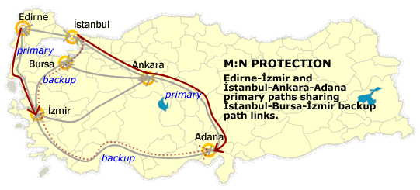

3. What is traffic grooming? When do we need to use grooming capability?
The process of grouping many small communication flows into larger units that could be processed itself, is called traffic grooming.

In optical networks, a lightpath has a bandwidth of 10 Gbps for today’s usage and expected to be 40 Gbps soon which is very high for most of the users. Many of the users need lower bandwidths. Therefore, high bandwidth wavelength channels are filled up by many low-speed traffic streams with grooming the traffic in order to provision customer connections efficiently.

Grooming capability is important in dynamically changed wavelength channels, and should be used in the networks that have many low-speed traffic usages.

4. What are the inputs of a static traffic grooming problem?
The inputs of the static traffic grooming problem are:

- The physical topology $G_{p}=(V,E_{p})$ consisting of a weighted unidirectional graph where $V$ is the set of network nodes and $E_{p}$ is the set of physical links.
- Number of wavelength channels W that are carried by each optic fiber.
- Capacity C of each wavelength.
- $N=\left|V\right|$ traffic matrix which represents one particular group of low-speed connection requests between nodes of the network.
- The number of transceivers ${\text{TR}}_{i}$ and receivers ${\text{RR}}_{i}$ at each node i.

5. Explain each block in the figure on slide 14. Explain how the grooming switch performs the grooming operation, when necessary.

The node architecture is composed of two components.

- The WRS performs wavelength routing and wavelength multiplexing/demultiplexing.
WRS is composed of optical cross-connect (OXC), network control management unit (NC&M), and optical multiplexer/demultiplexer.
NC&M has two parts:
- The network-to-network interface (NNI) will configure OXC and exchange control messages with pear nodes on a dedicated wavelength channel.
- The network-to-user interface (NUI) will communicate with the NNI and exchange control information with the user-to-network interface (UNI), that is control component of the access station.
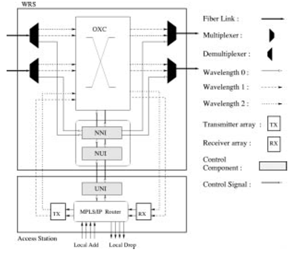

- The access station provides a flexible, software based bandwidth provisioning capability to the network.
- MPLS/IP router uses a software based queuing scheme that multiplexes low-speed connections to high-capacity lightpaths.
- TX and RX are transmitters and receivers where the optical signals are send out and emit respectively.

In the figure each access station is equipped with several SONET add-drop multiplexers (ADMs), that has the ability to separate a high-rate SONET signal into lower rate components and the reverse operation. In the reverse operation, using the TDM-based fast multiplexing /demultiplexing methods, the grooming operation is performed when necessary. | 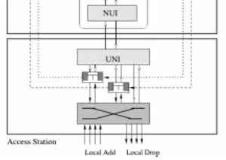

6. Describe grooming ratio.

Using the wavelength capacity OC-N in the network, assume that the lowest input port speed of the electronic switch fabric is OC-M. The grooming ratio is
$$ρ=\frac{N}{M}\left(N≥M\right)$$
which shows the maximum number of grooming that could be done for each wavelength.

7. Study the Maximizing Single-hop Traffic heuristic from the paper:
“Traffic Grooming in an Optical WDM Mesh Network”, Keyao Zhu, and Biswanath Mukherjee, IEEE Journal on Selected Areas in Communication, Vol.20, No.1, Jan. 2002.
Explain the algorithm in your own words. How do you think the algorithm can be improved?

Let T(s, d) denote the traffic between node s and d, which has not been successfully carried (sum of uncarried traffic request).

The algorithm consisting of two parts:

- Constructing the virtual topology:
- At first, all (s, d) node pairs will be sorted in decreasing order into a list L according to T(s, d).
- After creating the list L, choose the first node pair (s’, b’) from L and try to setup a lightpath between s’ and d’ using first-fit wavelength assignment and shortest path routing algorithm in the view of wavelength and transceiver constraints.
- If we could setup a lightpath, change T(s, d) = max[T(s, d)-C, 0] and start with the changed list. On the other hand, if lightpath could not be setup, remove it from L. Continue these processes until the list will be empty.
- Routing the low-speed connections on the virtual topology constructed in part 1.
- In the second part, satisfy all single-hop lightpaths and update the virtual topology network state.
- After creating new virtual topology, route the remaining connection requests in the descending order of connections’ bandwidth requirement.

In order to improve the algorithm these could be done:

- The list could be sorted list, in order to decrease the calculations done in first part in each step.
- Main List could be merged into small lists depends on different source nodes. Therefore, calculating the lengths of lists, we could process nodes that have more elements in the beginning according to the same algorithm. As a result, processing each node independently and finish one by one may improve the performance (?).
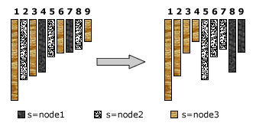
- In second part, using weighted lightpaths could improve the performance; however, it will increase the calculations.

