Optical Networks

Homework II

Ph. D. Ayşegül Yayımlı

Beycan Kahraman
504071508

Optical Networks  Ph. D. Ayşegül Yayımlı | Beycan Kahraman  504071508
Homework 2 | 31.10.2007

1. Define the routing and wavelength assignment problem.

For given a set of lightpaths that are needed to be established on the network and a constraint on maximum number of wavelengths; determining the routes over which the lightpaths should be set up and the wavelengths that are assigned to lightpaths, with the usage of maximum numbers of lightpaths is called routing and wavelength assignment problem.

2. What is a virtual topology?

Using the benefits of both electronics and optics, with the help of multiplexers and optical switches in routing nodes; the physical topology could be improved to some virtual topologies in order to prevent setting up lightpaths between all user pairs and to create multi-hopping between lightpaths.

3. Draw an example network to describe the wavelength continuity constraint, and explain.

If a lightpath uses the same wavelength on all fiber links that it traverses, the lightpath is said to satisfy the wavelength-continuity constraint. However, with the usage of wavelength converters the lightpath could change its wavelength in some nodes which causes the wavelength-continuity constraint to disappear.

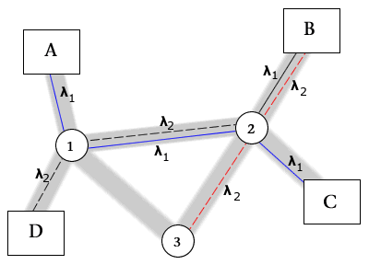

We have 2 wavelengths for this example shown in figure. Assume that there is a connection established between A-C with the path A-1-2-C at wavelength λ₁, which satisfies wavelength-continuity constraint. However, since B establishes a connection with C at wavelength λ₂, when it tries to communicate with D with the path B-2-1-D, it tries to use λ₁. As a result, the lightpath is converted from wavelength λ₁ to λ₂, where wavelength-continuity constraint is disappeared.

4. Give the ILP formulation for RWA problem, and explain each equation set.

The routing and wavelength assignment problem can be decomposed into sub-problems and each sub-problem could be solved independently in easier methods. We will examine the integer linear program formulation for RWA problem.

Let λ_{sd} denotes the traffic from source s to destination d. λ_{sd} could be 1 as there exists a lightpath between s and d, or be 0 as no lightpath existence. In addition, F^{sd}_{ij} denotes the traffic from source s to destination d on link ij.

Therefore integer linear program (ILP) formulation is as follows:

We will try to minimize F_{max} total usage of the network.

$$\text{Minimize}:F_{\text{max}}$$
Here
$$λ_{\text{sd}}=0, 1$$
denotes the existence of lightpath between s and d as a Boolean.
$$F_{\text{ij}}^{\text{sd}}=0, 1$$
denotes the traffic between s and d on link ij as a Boolean.

Since all the traffic from s to d on link ij is denoted by $F_{\text{ij}}^{\text{sd}}$, we will try to decrease the sum of all traffic on the network. Consequently, we will try to decrease $F_{\text{max}}$ by decreasing the sum of all $F_{\text{ij}}^{\text{sd}}$ values.
$$F_{\text{max}}≥\sum_{s,d}{F_{\text{ij}}^{\text{sd}}}∀i,j$$

$$\sum_{i}{F_{\text{is}}^{\text{sd}}}+λ_{\text{sd}}=\sum_{k}{F_{\text{sk}}^{\text{sd}}}$$
(s = j) means that: since j is a source point, the incoming link usage is one smaller than outgoing link usage because of possible newly created lightpath.
$$\sum_{i}{F_{\text{id}}^{\text{sd}}}=\sum_{k}{F_{\text{dk}}^{\text{sd}}+λ_{\text{sd}}}$$
(d = j) expresses that, since j is a destination point, there will be one more incoming link for destination node.
$$\sum_{i}{F_{\text{ij}}^{\text{sd}}}=\sum_{k}{F_{\text{jk}}^{\text{sd}}\text{otherwise}}$$
The formula means: for fixed point j, the incoming link usage is equal to outgoing link usage.

We could write all of these equations in uniform as written below.

$$\sum_{i}{F_{\text{ij}}^{\text{sd}}}−\sum_{k}{F_{\text{jk}}^{\text{sd}}}=\begin{aligned}\left\{−λ_{\text{sd}}\text{if} s=j | \right.\left\{λ_{\text{sd}}\text{if} d=j | \right.\end{aligned}$$

5. Define static lightpath establishment and dynamic lightpath establishment problems. What are the differences between these two problems?

The connection requests in a network may be of three type, two of whom are static lightpath establishment (SLE) and dynamic lightpath establishment (DLE). In static form, all the connections is known in advance and the aim is setting the lightpaths for connections in a global fashion while minimizing network sources. However in dynamic form, a lightpath is set up for each connection request as it arrives. After giving a brief introduction to these problems lets explain them.

Static lightpath establishment problems’ objective is minimizing the number of the wavelengths used. The physical topology and lightpath requests are known. Therefore, the SLE problem could be formulated as ad integer linear problem that minimizes the flow in each link.

On the other hand, for dynamic lightpath establishment problem there are two main problems: routing sub-problem and wavelength assignment sub-problem. For dynamic case, linear programming is not an option. As a result, we try to benefit from heuristics in spite of using globally optimal algorithms.

Static problem has a globally linear method to be solved. However in dynamic problem, we could only use heuristics. In static problem the physical topology and lightpath requests are known, however, the lightpath requests are not stable in dynamic problem.

6. Solve problem 7.6 in the text book. (Show the solution in colors.)

Consider the network in Fig. 7.1, and the following lightpaths:
(a) C-7-8-9-E
(b) A-1-5-8-9-E
(c) H-2-1-5-8-7-C
(d) B-6-7-8-9-E
(e) A-1-6-7-10-D
(f) G-3-2-1-6-B
(g) H-2-3-4-F
Color the lightpaths using the minimum number of wavelengths.

There are many solutions to this problem. We will solve it in two cases.

i. In first case, there are no wavelength converters in switching nodes. Therefore, we should use at least 5 different wavelengths.

The lightpaths (e) and (g) are independent, so they may use the same wavelength. In addition, (a) and (f) are independent. Therefore, we should use minimum number of 5 different wavelengths in order to form this network.
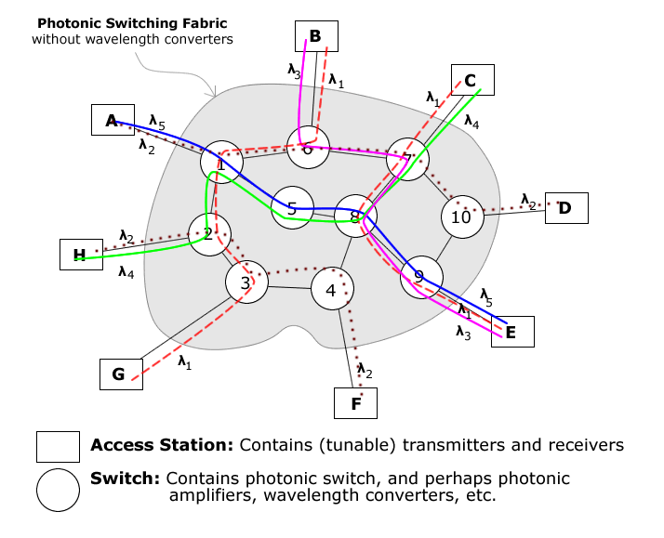

ii. In second case, by the acceptance of using 3x3 Active Switches, it is enough for using 3 different wavelengths in order to create the given network topology.

