Optical Networks  Dr. Ayşegül Yayımlı | Beycan Kahraman  040020337
Homework 1 | 17.10.2007

1. What are the types of amplification in optical Networks? Explain each of them shortly.

There are three types of amplification in optical networks: 1R (re-amplification), 2R (re-amplification & re-shaping) and 3R (re-amplification & re-shaping & re-timing).

1R: In this type of amplification, there is no shaping or timing processes. Only the signal will be amplified.

2R: In this type, the signal will be converted into electronic world. Then it will be modulated by a laser directly.

3R: Recently the worthiest type of amplification, which includes all amplification, shaping and timing processes is 3R. The signal amplified by converted to electronic data and then retransmitted in optical way again.

2. What is the basic difference between opaque and transparent switching?

Opaque switching and transparent switching are differ with their signal carriers. In opaque switching, also called logic switching, the switching device is controlled by the carried data by combinations of some Boolean functions.

However, in transparent switching, the switching job is controlled electronically by a given input. Therefore the switch is independent of the data, format of the signal and the presence of individual bits.

3. Draw a 16X16 optical cross connect formed of 2X2 switching elements.

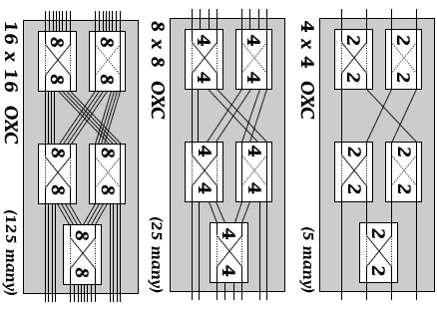
Schema: Using standardized 2x2 OXCs, create all 4x4, 8x8 and 16x16 OXCs
4. Explain the operation principles of EPON in downstream and upstream directions. Why is the timeslot assignment to ONU (optical network units) important in EPON?

In downstream direction (OLT to ONU), transmitted Ethernet frames from OLT (optical line terminal) passes using a 1:N passive splitter and may reach each ONU. These passive splitters are common in use with 1:8 and 1:32 dimensioned. EPON (Ethernet PON) operation is broadcast for downstream direction. Packets are broadcast by OLT and send to destination ONU determined by LLID (logical link identifier). Whenever ONU registers with the network, LLID assign it to active ONU list.

In upstream direction, the behavior of EPON is similar to point-to-point architecture by using passive optical combiners. As a result, data sent from ONU could not reach other ONUs. However, in the combine process, data transmitted simultaneously could be colliding. Eventually, we need a arbitration mechanism to line up the data to avoid collisions. Since ONUs cannot detect a collision in the fiber, we could not benefit from a content based media-access mechanism. On the other hand, whenever OLT notices a collision, it informs ONU by a jam signal. Still there will be performance problems with larger propagation delayed systems. In order to introduce determinism in frame delivery, different non-contention schemes have been proposed.

The timeslot assignment to ONU is important in EPON for preventing collision problems occurred in upstream direction. As a result, there is no need for jam messages from OLT and timeslot technique solves the performance problems with larger propagation delayed systems.

5. What are the different PON topologies and what are the advantages of each of them?

There are three types of PON topologies: tree topology, tree and branch topology, bus topology and ring topology (also double rings and double trees).

PON topologies have some general advantages like: availability for long distances about 20km, minimizing fiber deployment, providing higher bandwidth solutions due to deeper fiber penetration, operating in downstream direction as a broadcast network, eliminating the necessity of installing active multiplexers and being transparent to end-to-end.

In electronic systems, bus topology needs minimal wire and cheap hardware. In addition it is easy to install. However, ring topology allows more computers to connect to the network than bus topology. On the other hand, tree topology could have hierarchical harmony in design.

Examining PON topologies in optical networks, the switching elements are the most important parts of the network parts. As a result, tree topologies need only one switch and easy and inexpensive to implement.

6. Why is it important to have a passive element in an access network?

It is important to have a passive element in an access network, because passive elements are inexpensive than active elements and are not require power to work. In fact, passive elements work on optical world without optical-to-electrical conversion.
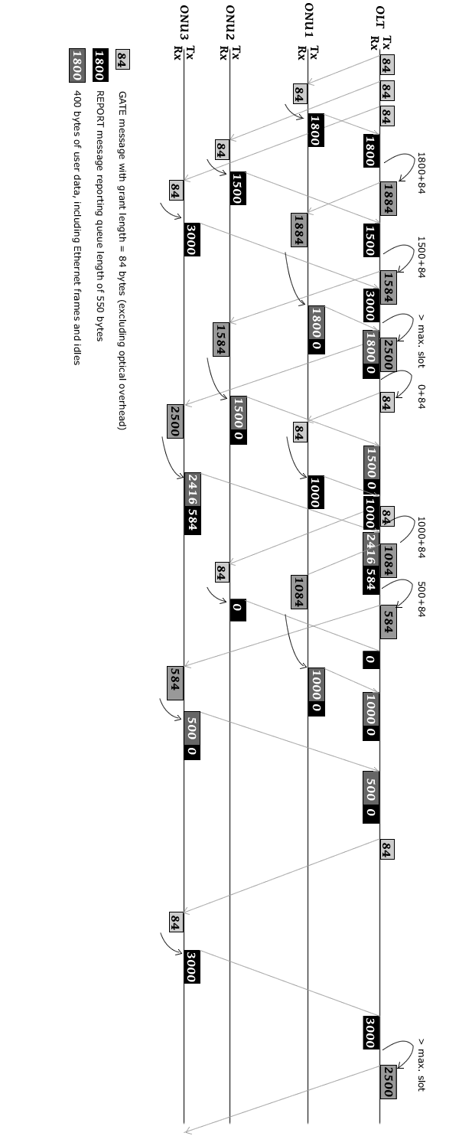  Figure: Timing diagram of the limited-service scheme in IPACT | 7. Consider the IPACT protocol with the limited service scheme, and a maximum scheduling timeslot WMAX of 2500 bytes. Assume the following sequence of requests as shown in Table. Assume RTTs are constant but different for different ONUs and a 5-μs guard timeslot between data  transmissions of different ONUs. The polling order starts with ONU 1.Draw a timing diagram for a 3-ONU EPON system, similar to the timing  diagram we have seen class. Give proper explanations on your diagram.  ONU Request 1 Request 2 RTT  1 1800 1000 100  2 1500 0 200  3 3000 3000 250

