MAT 342E – Differential Geometry | HOMEWORK II | Assigned Date: 28.02.2007  Due Date: 07.03.2007

QUESTION 1

Student Number: 040020337 | e-mail: beycan@mail.com | Name: Beycan | Surname: Kahraman | Grade:

Find the intersection of the $\text{xy}$ plane and the tangent lines to the helix
$$\vec{α}(t)=\text{cos}t\text{.}{\vec{e}}_{1}+\text{sin}t\text{.}{\vec{e}}_{2}+t\text{.}{\vec{e}}_{3}t>0\text{.}$$

SOLUTION

Let’s find the tangent line at a given point:
$$−∞<λ<∞$$
$$\vec{r}(t_{0})=\vec{α}(t_{0})+λ\vec{α}'(t_{0})−∞<λ<∞$$

$$\begin{aligned}\left.x=\text{cos}t_{0}−λ\text{sin}t_{0} | \right\}\left.y=\text{sin}t_{0}+λ\text{cos}t_{0} | \right\}\end{aligned}−∞<λ<∞,t_{0}>0$$
Here we have found the tangent lines of the helix for all chosen points. When we want to find the intersection of the xy plane with these lines, we will calculate the values for $z=0$.

For $z=0$(on the xy plane) we could find the intersection equation as:
$λ=t_{0}$
$\begin{aligned}\left.x=\text{cos}\left|t\right|−λ\text{sin}\left|t\right| | \right\}\end{aligned}−∞<t<∞$ in parametric form.
When we plot the graph of the equation, we get:
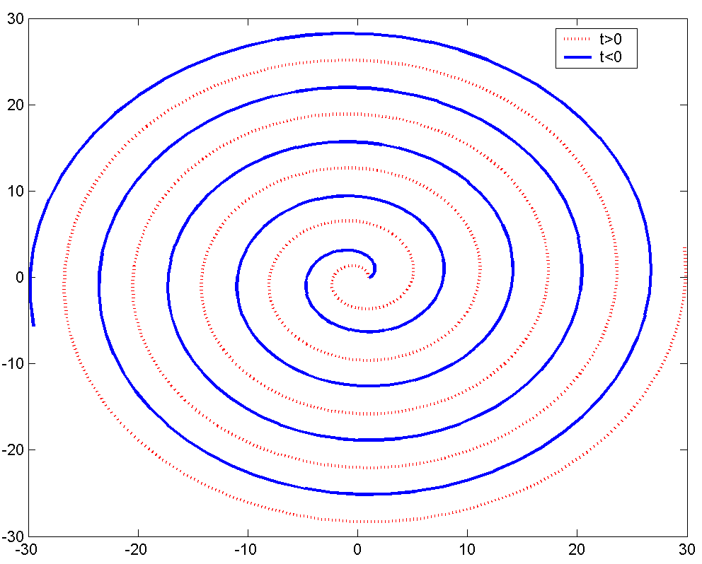

MAT 342E – Differential Geometry | HOMEWORK II | Assigned Date: 28.02.2007  Due Date: 07.03.2007

QUESTION 2

Student Number: 040020337 | e-mail: beycan@mail.com | Name: Beycan | Surname: Kahraman | Grade:

a) Find the curvature of the following curve
$\vec{α}(t)=t\text{.}{\vec{e}}_{1}+\frac{1+t}{t}\text{.}{\vec{e}}_{2}+\frac{1−t^{2}}{t}\text{.}{\vec{e}}_{3}$.
b) Prove that the curvature of the plane curve $y=f(x)$ is given by $κ=\frac{\left|f\text{''}(x)\right|}{(1+f'^{2})^{3/2}}$.

SOLUTIONS

a) $κ=\frac{\left|\vec{α}'×\vec{α}\text{''}\right|}{{\left|\vec{α}'\right|}^{3}}$
$\vec{α}'(t)={\vec{e}}_{1}−\frac{1}{t^{2}}\text{.}{\vec{e}}_{2}−\frac{t^{2}+1}{t^{2}}\text{.}{\vec{e}}_{3}$
$$\vec{α}\text{''}(t)=0\text{.}{\vec{e}}_{1}+\frac{2}{t^{3}}\text{.}{\vec{e}}_{2}+\frac{2}{t^{3}}\text{.}{\vec{e}}_{3}$$
$$\vec{α}'(t)×\vec{α}\text{''}(t)=\begin{aligned}\left|{\vec{e}}_{1} {\vec{e}}_{2} {\vec{e}}_{3} | \right|\left|1−\frac{1}{t^{2}}−\frac{t^{2}+1}{t^{2}} | \right| \\ \end{aligned}$$
$$\left|\vec{α}'×\vec{α}\text{''}\right|=\sqrt{\frac{4}{t^{6}}+\frac{4}{t^{6}}+\frac{4}{t^{6}}}=\frac{2\sqrt{3}}{t^{3}}$$
$$\left|\vec{α}'\right|=\sqrt{1^{2}+\frac{1}{t^{4}}+\frac{t^{4}+2t^{2}+1}{t^{4}}}=\sqrt{\frac{2t^{4}+2t^{2}+2}{t^{4}}}=\frac{\sqrt{2}\sqrt{t^{4}+t^{2}+1}}{t^{2}}$$
$$κ=\frac{\left|\vec{α}'×\vec{α}\text{''}\right|}{{\left|\vec{α}'\right|}^{3}}=\frac{\frac{2\sqrt{3}}{t^{3}}}{\frac{2\sqrt{2}\left(t^{4}+t^{2}+1\right)\sqrt{t^{4}+t^{2}+1}}{t^{6}}}=\frac{\sqrt{3}t^{3}}{\sqrt{2}{\left(t^{4}+t^{2}+1\right)}^{3/2}}$$

b) $y=f(x)$ so we take $z=0$. Let $\vec{α}(x)=x\text{.}{\vec{e}}_{1}+f(x)\text{.}{\vec{e}}_{2}+0\text{.}{\vec{e}}_{3}$,
$κ=\frac{\left|\vec{α}'×\vec{α}\text{''}\right|}{{\left|\vec{α}'\right|}^{3}}=$

MAT 342E – Differential Geometry | HOMEWORK II | Assigned Date: 28.02.2007  Due Date: 07.03.2007

QUESTION 3

Student Number: 040020337 | e-mail: beycan@mail.com | Name: Beycan | Surname: Kahraman | Grade:

For the parametrized curve
$\vec{α}(t)=e^{t}\text{.}\vec{i}+e^{−t}\text{.}\vec{j}+\sqrt{2}t\text{.}\vec{k}$,
Find the moving frame $\vec{T}$, $\vec{N}$, $\vec{B}$ and torsion $τ$.

SOLUTION

Let’s find the moving frame:

$\vec{α}'(t)=e^{t}\text{.}\vec{i}−e^{−t}\text{.}\vec{j}+\sqrt{2}\text{.}\vec{k}$
$$\vec{T}=\frac{α'}{\left|α'\right|}=\frac{e^{t}\text{.}\vec{i}−e^{−t}\text{.}\vec{j}+\sqrt{2}\text{.}\vec{k}}{\sqrt{e^{2t}+2+e^{−2t}}}=\frac{e^{t}\text{.}\vec{i}−e^{−t}\text{.}\vec{j}+\sqrt{2}\text{.}\vec{k}}{e^{t}+e^{−t}}=\frac{e^{t}}{e^{t}+e^{−t}}\text{.}\vec{i}−\frac{e^{−t}}{e^{t}+e^{−t}}\text{.}\vec{j}+\frac{\sqrt{2}}{e^{t}+e^{−t}}\text{.}\vec{k}$$

$\vec{α}\text{''}(t)=e^{t}\text{.}\vec{i}+e^{−t}\text{.}\vec{j}+0\text{.}\vec{k}$
$α'×α\text{''}=\begin{aligned}\left|\vec{i}\vec{j}\vec{k} | \right|\left|e^{t}−e^{−t}\sqrt{2} | \right| \\ \end{aligned}$

$$\vec{B}=\frac{α'×α\text{''}}{\left|α'×α\text{''}\right|}=\frac{−\sqrt{2}e^{−t}\text{.}\vec{i}+\sqrt{2}e^{t}\vec{j}+2\vec{k}}{\sqrt{2e^{−2t}+2e^{2t}+4}}=\frac{−\sqrt{2}e^{−t}\text{.}\vec{i}+\sqrt{2}e^{t}\vec{j}+2\vec{k}}{\left(e^{−t}+e^{t}\right)\sqrt{2}}=−\frac{e^{−t}}{e^{−t}+e^{t}}\text{.}\vec{i}+\frac{e^{t}}{e^{−t}+e^{t}}\vec{j}+\frac{\sqrt{2}}{e^{−t}+e^{t}}\vec{k}$$

$$\vec{N}=\vec{B}×\vec{T}=\begin{aligned}\left| \vec{i} \vec{j} \vec{k} | \right|\left|−\frac{e^{−t}}{e^{−t}+e^{t}} \frac{e^{t}}{e^{−t}+e^{t}} \frac{\sqrt{2}}{e^{−t}+e^{t}} | \right| \\ \end{aligned}$$

And lastly we will find torsion,

$\vec{α}\text{'''}(t)=e^{t}\text{.}\vec{i}−e^{−t}\text{.}\vec{j}+0\text{.}\vec{k}$
$\left(\vec{α}\text{', \{}\vec{α} | | \text{'', \{}\vec{α} | | \text{'''}\right)=\begin{aligned}\left|e^{t}−e^{−t}\sqrt{2} | \right|\left|e^{t}e^{−t}0 | \right| \\ \end{aligned}$
$$τ=\frac{\left(\vec{α}\text{', \{}\vec{α} | | \text{'', \{}\vec{α} | | \text{'''}\right)}{{\left|α'×α\text{''}\right|}^{2}}=−\frac{2\sqrt{2}}{2e^{−2t}+2e^{2t}+4}=−\frac{\sqrt{2}}{{\left(e^{−t}+e^{t}\right)}^{2}}$$

MAT 342E – Differential Geometry | HOMEWORK II | Assigned Date: 28.02.2007  Due Date: 07.03.2007

QUESTION 4

Student Number: 040020337 | e-mail: beycan@mail.com | Name: Beycan | Surname: Kahraman | Grade:

The curve $\vec{α}=\vec{α}(t)$ is a curve with arc-length parameter $s$, curvature $κ$, torsion $τ>0$, and a Frenet Trihedron $\vec{t}$, $\vec{n}$, $\vec{b}$. Suppose that
$$y(s)=\int_{0}^{s}{\vec{n}(p)\text{dp}}$$
Find the torsion $τ^{}$, of the curve $\vec{y}(s)$.

NO SOLUTION

$τ^{}=\frac{\left(\vec{\overset{˙}{y}},\vec{\overset{¨}{y}},\vec{\overset{⃛}{y}}\right)}{{\left(κ^{}\right)}^{2}}=\frac{\left(\vec{n}\text{', \{}\vec{n} | | \text{'', \{}\vec{n} | | \text{'''}\right)}{{\left|\vec{n}'×\vec{n}\text{''}\right|}^{2}}$
$\vec{t}=\frac{α'}{\left|α'\right|}$, $\vec{b}=\frac{α'×α\text{''}}{\left|α'×α\text{''}\right|}$, $\vec{n}=\vec{b}×\vec{t}$, $κ=\frac{\left|\vec{α}'×\vec{α}\text{''}\right|}{{\left|\vec{α}'\right|}^{3}}=\left|\vec{\overset{¨}{α}}\right|$

$\vec{n}=\frac{α'×α\text{''}}{\left|α'×α\text{''}\right|}×\frac{α'}{\left|α'\right|}=\frac{α'×α\text{''}×α'}{\left|α'×α\text{''}\right|\text{.}\left|α'\right|}=\frac{α'×α\text{''}×α'}{κ\text{.}{\left|α'\right|}^{4}}$

$α'=\overset{˙}{α}\text{.}s'$
$α\text{''}=\overset{¨}{α}\text{.}s'^{2}+\overset{˙}{α}\text{.}s\text{''}$

$α'×α\text{''}=\left(\overset{˙}{α}×\overset{¨}{α}\right)\text{.}s'^{3}=\left(\vec{t}×κ\vec{n}\right)\text{.}s'^{3}=κ\vec{b}\text{.}s'^{3}$

