MAT341E Theory of Complex Functions | Worksheet 1 | 9 October 2007
Beycan Kahraman
040020337

1. In each case, find all of the roots in the rectangular coordinates, exhibit them geometrically and point out which is the principal root.
a) ${\left(−1\right)}^{13}$  $\begin{aligned}z=−1, θ=−π, r=\sqrt{(−1)^{2}}=1 \\ z=1\text{.}e^{−iπ} \\ c_{k}=\sqrt[3]{z}=\sqrt[3]{1\text{.}}e^{i\frac{−π+2kπ}{3}}=e^{i\frac{2kπ−π}{3}} \\ c_{0}=e^{−i\frac{π}{3}},c_{1}=e^{i\frac{π}{3}},c_{2}=e^{i\frac{3π}{3}}\end{aligned}$  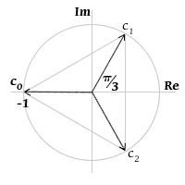 | c) $8^{16}$  $$\begin{aligned}z=8, θ=0, r=\sqrt{(8)^{2}}=8z=8\text{.}e^{i\text{.}0} \\ c_{k}=\sqrt[6]{z}=\sqrt[6]{8\text{.}}e^{i\frac{2kπ}{6}}=\sqrt{2}\text{.}e^{i\frac{2kπ}{6}} \\ c_{0}=\sqrt{2}\text{.}e^{−i\frac{π}{6}},c_{1}=\sqrt{2}\text{.}e^{i\frac{π}{6}},c_{2}=\sqrt{2}\text{.}e^{i\frac{3π}{6}}, \\ c_{3}=\sqrt{2}\text{.}e^{i\frac{5π}{6}},c_{4}=\sqrt{2}\text{.}e^{−i\frac{5π}{6}},c_{5}=\sqrt{2}\text{.}e^{−i\frac{3π}{6}}\end{aligned}$$  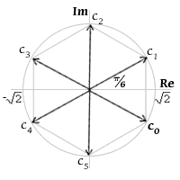
b) ${\left(−\text{16}\right)}^{14}$  $$\begin{aligned}z=−\text{16}, θ=−π, r=\sqrt{(−\text{16})^{2}}=\text{16} \\ z=\text{16}\text{.}e^{−iπ} \\ c_{k}=\sqrt[4]{z}=\sqrt[4]{\text{16}\text{.}}e^{i\frac{−π+2kπ}{4}}=2\text{.}e^{i\frac{2kπ−π}{4}} \\ c_{0}=2\text{.}e^{i\frac{−π}{4}},c_{1}=2\text{.}e^{i\frac{π}{4}}, \\ c_{2}=2\text{.}e^{i\frac{3π}{4}},c_{3}=2\text{.}e^{−i\frac{3π}{4}}\end{aligned}$$  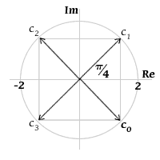 | d) ${\left(−8−8\sqrt{3}i\right)}^{14}$  $$\begin{aligned}z=−8−8\sqrt{3}i, θ=−\frac{2π}{3}, r=\sqrt{(−8)^{2}+(−8\sqrt{3})^{2}}=\text{16} \\ z=\text{16}\text{.}e^{−i\frac{2π}{3}} \\ c_{k}=\sqrt[4]{z}=\sqrt[4]{\text{16}\text{.}}e^{i\left(−\frac{2π}{\text{12}}+\frac{2kπ}{4}\right)}=2\text{.}e^{i\left(\frac{6kπ−2π}{\text{12}}\right)} \\ c_{0}=2\text{.}e^{−i\frac{π}{6}},c_{1}=2\text{.}e^{i\frac{π}{3}}, \\ c_{2}=2\text{.}e^{i\frac{5π}{6}},c_{3}=2\text{.}e^{−i\frac{2π}{3}}\end{aligned}$$  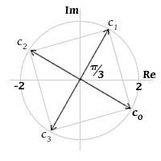

2. Find the principal argument $\text{Arg} z$ (use $−π<θ≤π$ branch) when
a) $z=\frac{−2}{1+\sqrt{3}i}$
$$z=\frac{−2}{1+\sqrt{3}i}=\frac{−2\left(1−\sqrt{3}i\right)}{\left(1+\sqrt{3}i\right)\left(1−\sqrt{3}i\right)}=\frac{−2\left(1−\sqrt{3}i\right)}{4}=\frac{−1}{2}+\frac{\sqrt{3}i}{2}⇒\text{Arg} z=\frac{2π}{3}$$

b) $z=\frac{i}{−2−2i}$
$$z=\frac{i}{−2−2i}=\frac{i\left(−2+2i\right)}{\left(−2−2i\right)\left(−2+2i\right)}=\frac{−i−1}{4}⇒\text{Arg} z=−\frac{3π}{4}$$

c) $z={\left(\sqrt{3}−i\right)}^{6}$
$$z={\left(2\text{.}e^{−i\frac{π}{6}}\right)}^{6}=\text{64}\text{.}e^{−iπ}⇒\text{Arg} z=−π$$

3. Solve the equation $\left|e^{iθ}−1\right|=2$ for $θ \left(0≤θ<2π\right)$ and verify the solution geometrically.
$$\begin{aligned}e^{iθ}−1=2∨e^{iθ}−1=−2 \\ \underset{r=1}{\underbrace{e^{iθ}}}=3e^{iθ}=−1 \\ \text{no} \text{solution}θ=−π+2kπ \\ k=0, 1, 2, \text{.}\text{.}\text{.}\end{aligned}$$ | 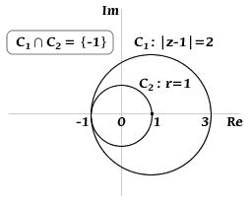

4. Show that if c is any $n$th root of unity other than unity itself, then$1+c+c^{2}+\text{.}\text{.}\text{.}+c^{n−1}=0$.
Hint: use the identity $1+z+z^{2}+\text{.}\text{.}\text{.}+z^{n}=\frac{1−z^{n+1}}{1−z}\left(z≠0\right)$

Since c is any $n$th root of unity other than unity itself$(c≠1)$, it holds the equation:
$$z^{n}=1⇒c^{n}=1$$
By using geometric series formula:
$\begin{aligned}1+c+c^{2}+\text{.}\text{.}\text{.}+c^{n−1}=\frac{1−c^{n}}{1−c} \\ 1+c+c^{2}+\text{.}\text{.}\text{.}+c^{n−1}=\frac{0}{1−c}=0 \\ \end{aligned}$
5. Sketch the following sets. Determine whether they are bounded or not.

a) $\left|z−2+i\right|≤1$  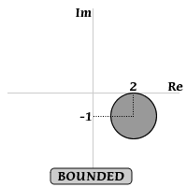 | b) $\left|2z+3\right|>4$  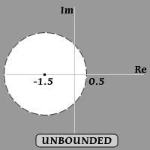
c) $\text{Im} z>1$  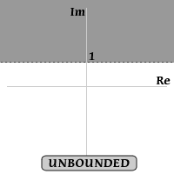 | d) $\text{Im} z=1$  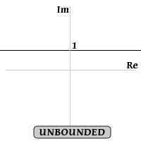
e) $0≤\text{arg} z≤\frac{π}{4} \left(z≠0\right)$  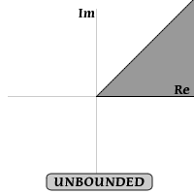 | f) $\left|z−4\right|≥\left|z\right|$  $${\left(x−4\right)}^{2}+y^{2}≥x^{2}+y^{2}⇒x≤2$$  