Optical Networks

Homework IV

Wavelength Assignment for Multicast
in All-Optical WDM Networks

Jianping Wang, Xiangtong Qi, Bian Chen
IEEE/ACM Transactions on Network Vol. 14

Ph. D. Ayşegül Yayımlı

Beycan Kahraman
504071508

Contents

Abstract
I. Introduction
II. Problem Description
III. Computational Complexity
IV. Heuristic Wavelength Assignment Algorithms
A. GWA Algorithm
B. MGWA Algorithm
C. WCR Algorithm
V. Performance Evaluation
VI. Program Simulation & Testing
VII. Summary

Abstract

Multicast is an important application in all optical WDM networks. The wavelength assignment problem for WDM multicast is to assign a set of wavelengths to the links of a given multicast tree. In the paper the computational complexity of the problem is studied. And also three heuristic algorithms are proposed and the worst-case approximation ratios for some heuristic algorithms are given. The efficiency of the proposed heuristic algorithms and the effectiveness of the derived bounds are verified by the simulation results.

I. Introduction

Wavelength division multiplexing (WDM) demonstrates great potential for the next-generation Internet by providing significant increase in network bandwidth. In general, we will study routing and wavelength assignment problem (RWA) for multicast in WDM optical network. For implementing WDM multicast, switches should be implemented with splitters.
There are two cases of splitting capability, full capability and partial capability. Power amplifiers are desired at a switch node in order to compensate for the power loss due to splitting. (G: splitters, X: incoming signals) If X<G all can be split whenever necessary, else at most G of them could be split.

II. Problem Description

Suppose T = (V, E) is a given multicast tree (V: the set of nodes v_{i}, E: set of directed links e_{i})
n: number of nodes in the multicast tree except root
Λ: set of all possible wavelengths in the system ( |Λ| = W )
Λ_{i}: set of available wavelengths on link e_{i}
B_{i}: set of indexes of the child nodes of node v_{i}
d_{i}: binary indicator, if v_{i} is a destination
G_{i}: number of splitters at node v_{i}
T_{i}: subtree rooted at node v_{i}
We will use cost c_{ik}, general cost function, which is both wavelength and link dependent
The optimal wavelength assignment problem studied in this paper is to find a subset of available wavelengths for each link e_{i} such that:
(1) The maximum number of destinations can be reached
(2) The wavelength cost is minimized under the condition of (1)
The problem is denoted as WA-cost. When we drop the secondary criterion, we denote it WA-des. Special cases with full splitting capability are WA-cost-FS and WA-des-FS.
The objective function could be:
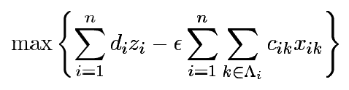
where
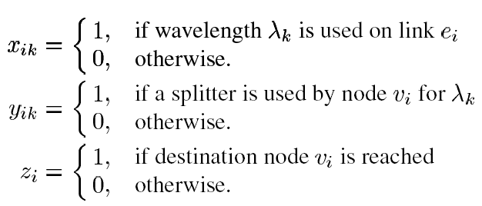
with constraints
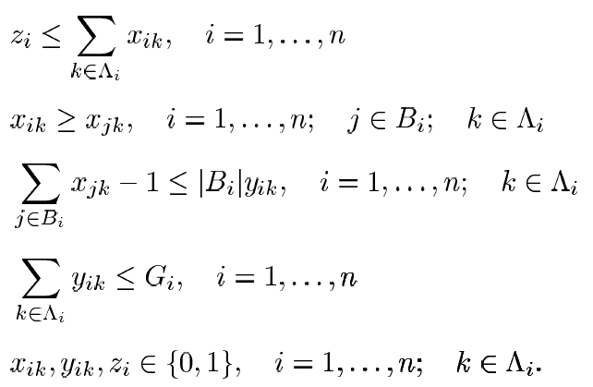

Let’s examine a WA-cost problem given in figure 1. The problem is given as 1 (a). We have the free wavelengths that could be used to multicast from root to the destinations.
One possible solution is given in 1 (b), where the cost is 6 and only 2 wavelengths are used.
However, in 1 (c), the cost is 5 and 3 wavelengths are used. Therefore, in order to our objective there could be many proper results.
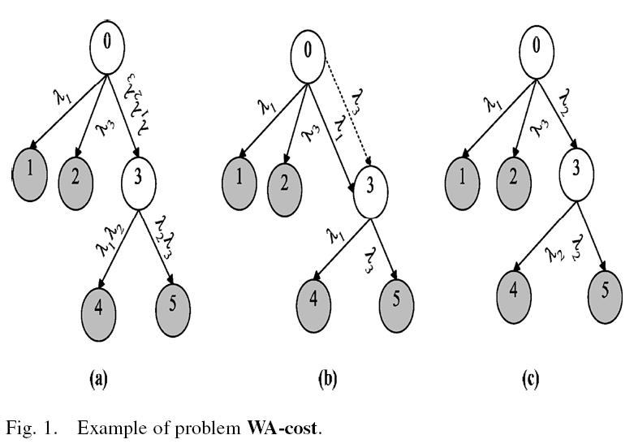
III. Computational Complexity

The decision version of the optimal wavelength assignment problem WA-cost is NP-complete. An addition, if all nodes have full splitting capability in the multicast tree, problem WA-des-FS of maximizing the number of reached destinations is solvable in polynomial time. With the splitting constraint, the decision version of the problem WA-des of maximizing the number of reached destinations is NP-complete. All of these results could be obtained from [D.S. Hochbaum, Approximation Algorithms for NP-Hard Problems. Boston, MA: PWS Publishing 1995].

IV. Heuristic Wavelength Assignment Algorithms

We propose three heuristic algorithms for the optimal wavelength assignment problem. Greedy Wavelength Assignment (GWA) Algorithm is an iterative approach which selects one wavelength in each iteration and eliminates some destinations in a greedy way. The remaining two algorithms are proposed to solve WA-cost-FS (full splitting). Modified GWA uses a different criterion to select the wavelength in each iteration. Wavelength Cost Ratio (WCR) Algorithm works with a new cost function.

A. GWA Algorithm

GWA Algorithm operates iteratively with each iteration consisting of the following two steps: First of all, for each branch of the root, choose a single wavelength such that the maximum number of destinations can be reached in this branch with the minimum cost. This is done by a simple dynamic programming (SDP) algorithm until the number of reached destinations are zero. Prune all destinations that can be reached by the wavelengths selected by the SDP algorithm and revise the number of available splitters in each node, which is implemented by a Prune Algorithm.

SDP Algorithm

The purpose of the SDP algorithm is to choose a single wavelength for each link in the multicast tree to maximize the number of reached destinations with the minimum cost. C_{n}(T_{i},λ_{k}): the maximum number of reached destinations in subtree T_{i} when wavelength λ_{k} is used.
C_{w}(T_{i},λ_{k}): the minimum cost of subtree T_{i} when wavelength λ_{k} is assigned to T_{i}.
branch(i,λ_{k}): the number of branches at node v_{i} in which at least one destination can be reached by wavelength λ_{k}. ( note that branch(i,λ_{k})>1 means a splitter is required )
- Calculating C_{n} and C_{w} at leaf nodes in two cases: G_{i} > 0 and G_{i} = 0.
G_{i} is not important in calculating C_{n} and C_{w}. C_{n} = 1 if d_{i} = 1, C_{n} = 0 else. On the other hand, C_{w} = c_{ik} if d_{i} = 1, C_{w} = 0
- Calculating C_{n} and C_{w} at intermediate nodes in two cases: G_{i} > 0 and G_{i} = 0.
G_{i} has a role in calculating C_{n} and C_{w} at intermediate nodes. If G_{i} = 0, we choose C_{n} to be the max(C_{n}) of the childs and choose C_{w} to be min(C_{w}) of the childs. On the other hand, if G_{i} > 0, it means that there is a splitting capability; so that we could sum the total C_{n}‘s.
As a result, by SDP algorithm, we can obtain a single optimal wavelength for each branch of the root node. The computational complexity of SDP is given by O(n|Λ|)

Prune Algorithm

The purpose of the prune algorithm is to delete the destinations that have been reached by the wavelengths selected by the SDP algorithm so that they are not considered in later iterations.
In the algorithm we should update available splitters and wavelengths for each node after deleting the destinations.

Procedure Prune(i, λ_{k}):
If node v_{i} is leaf, delete v_{i} and link e_{i}
If v_{i} is non-leaf, set d_{i} = 0
If G_{i} > 0 and branch(i, λ_{k}) > 1, G_{i} = G_{i} – 1
Set λ_{k} to be unavailable on link e_{i}
For each child of v_{i}, call Prune(j, λ_{k})
Time complexity of Prune Algorithm is O(n|Λ|min{n,Λ})

GWA Algorithm always tries to reach as many destinations as possible in each iteration. Such a greedy idea may fall into a local optimum because it does not look at the problem from a global view.

The GWA Algorithm has an approximation ratio of 1 – 1/e with respect to the number of reached destinations

B. MGWA Algorithm

Say λ₁ can reach 5 destinations with 30 cost. 2 of these destinations can be switched by λ₂ with cost of 12 and other 3 of them can be switched by λ₃ with cost of 10. GWA will choose first one. If we choose λ_{k} that satisfies (smallest average) the equation instead of choosing the maximum reached destinations we get MGWA Algorithm.
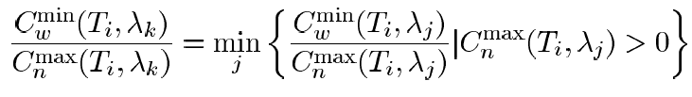
For problem WA-cost-FS, the MGWA Algorithm has an approximation ratio of 1 + ln n with respect to total wavelength cost.

C. WCR Algorithm

There are C_{n}(T_{i},λ_{k}) maximum number of reached destinations. Assume that c_{ik} is shared by all C_{n}(T_{i},λ_{k}). Then it can be regarded as that each destination shares a cost of w_{ik} = c_{ik} / C_{n}(T_{i},λ_{k}) which is called wavelength cost ratio (WCR). A wavelength with smaller WCR should be used to decrease wavelength cost. We could create the algorithm in two cases:
Run a similar dynamic programming SDP to calculate WCR for each link
Assign wavelengths to the paths for each leaves according to minimal WCR.
Computational complexity of WCR is O(n|Λ|). WCR algorithm is worse than MGWA Algorithm with respect to worst-case approximation ratio. However, WCR actually has a better average performance.

V. Performance Evaluation

We first introduce the simulation design:
N: number of nodes
W: number of wavelengths on each link
S_{N}: number of destinations
r: splitting factor
D: the out degree of each node
K: available wavelengths on each link {W/2 -> W}
Each node assigned r.W splitters
We create a random network. Choose a random source. Find all shortest paths from source to other nodes. If there will be any un-pathed destination, re-run the creation.

We use relative error compared with the lower bound to show the effectiveness of the heuristics. Let the lower bound of the cost be C_{LB}. Then the relative error of each algorithm will be:
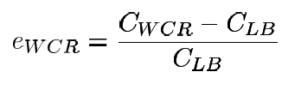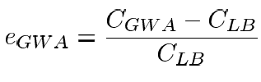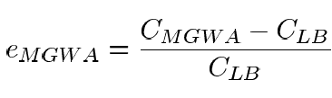

Minimization of Total Costs

Maximization of the Number of Reached Destination
Let the upper bound of the number of reached destinations be UB, and the maximum number of reached destinations found by the GWA algorithm is given by D_{GWA}. Then relative error could be defined as follows:
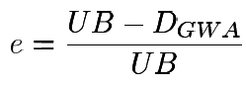

VI. Program Simulation & Testing

i. Introduction of the Program

I have created a simulation program for testing the results on the paper in Java programming language with Eclipse 3.3.1.1 SDK.  There are 8 classes in the simulation program.  We have created GWA, MGWA and WCR algorithm classes which have a very similar design. In all algorithms, we first find the best path to delete with an SDP (Simple Dynamic Programming Algorithm). After that, we have pruning this path, not to use in future iterations.  UpperBound and LowerBound classes have a similar design with the three algorithms introduced above. In upper bound we try to maximize the number of destination nodes with breaking wavelength continuity constraint. Therefore it will be an upper bound for the | 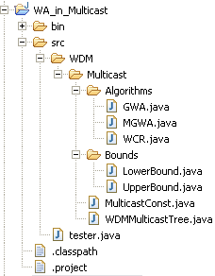
tests. In contrast, in LowerBound class we try to find a lower bound for the network cost with adding all WCRs (Wavelength Cost Ratios).

All the constants that are used in the simulation program are in the MulticastConst class.
WDMMulticasstTree class is where the random network is created. In addition, the randomized destinations and randomized available wavelengths are calculated there. And lastly class tester is where we test the simulation results and run the program.

ii. Program Flow

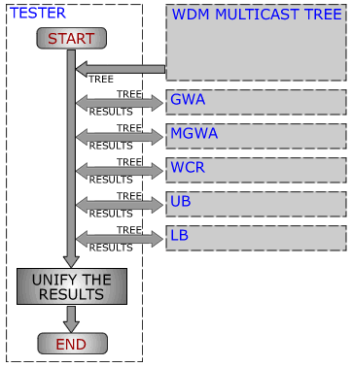 | First of all we have created WDM Multicast Tree and randomized destination nodes with initializing WDMMulticasstTree. Available wavelengths and splitting capabilities are also initialized in this class.  After we have created the wdmTree, we will call each algorithm to find its optimal solution according to its algorithm. For each step we have save the test results for getting the simulation results.  When we have the simulation results, we are ready to draw them in a simple MATLAB program.
ii. Simulation Results

We have plot the results in MATLAB after getting the result matrixes. For upper bound tests we have no problem and the simulation tests look like the paper results.

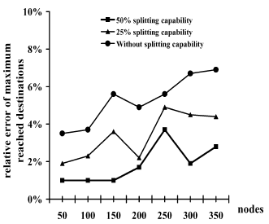 | 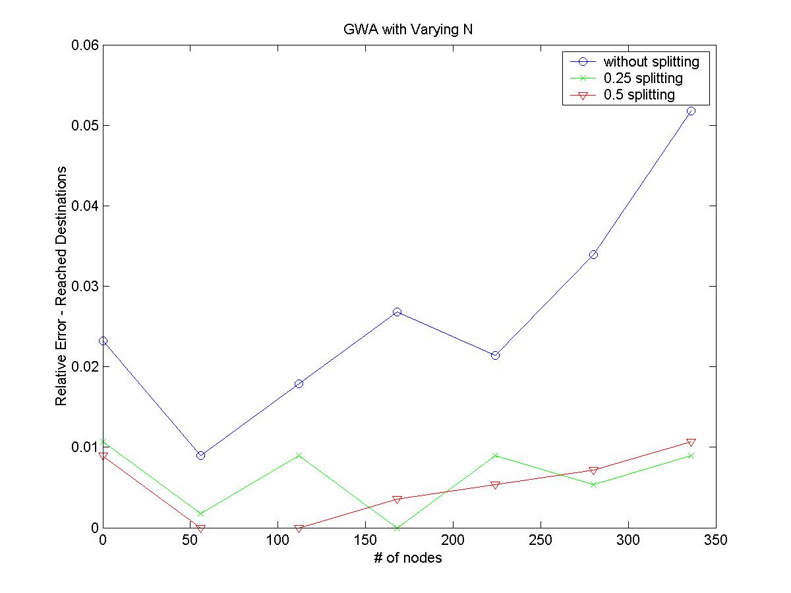
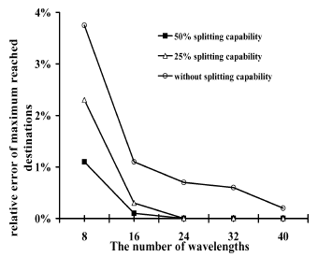 | 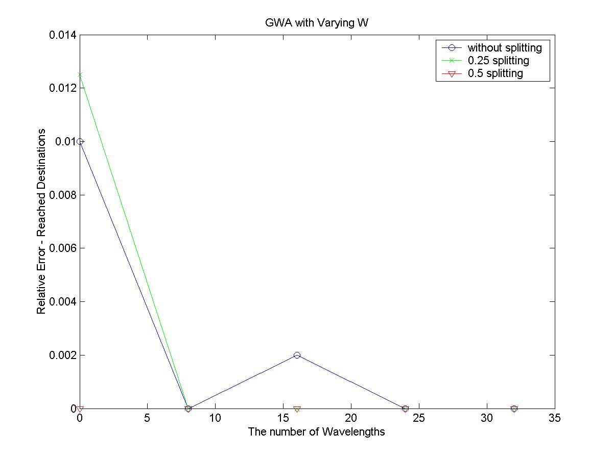
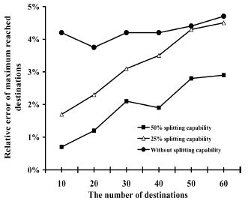 | 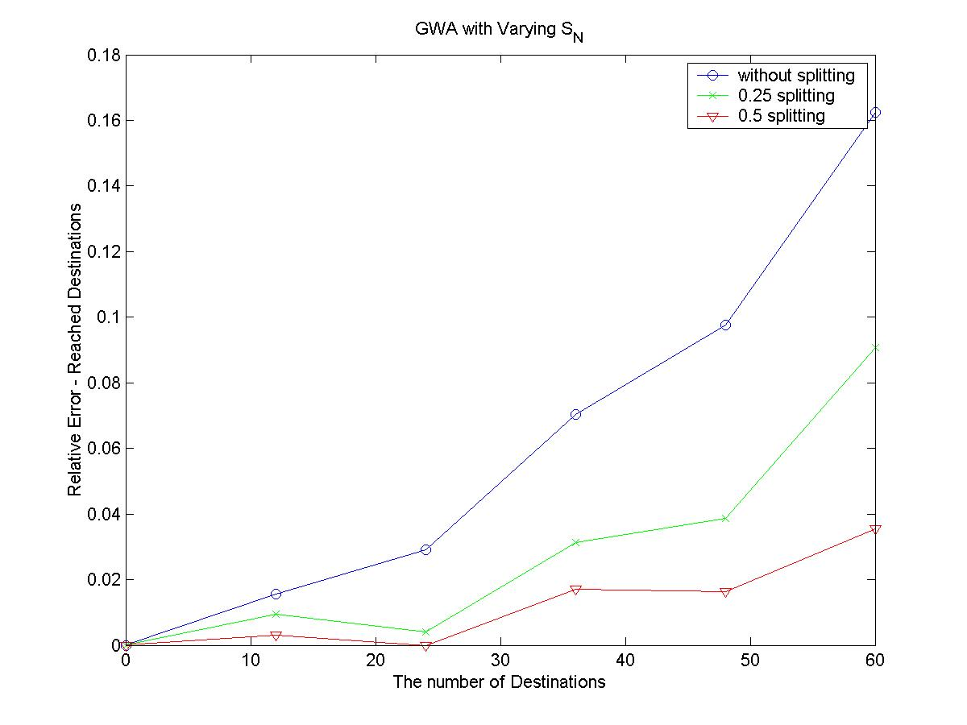
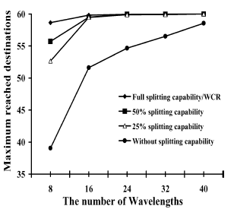 | 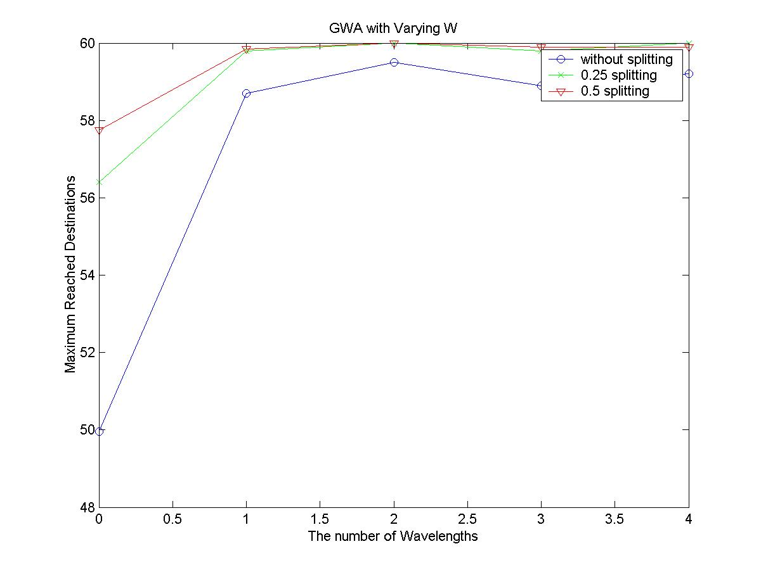

In simulation, we could simulate the tests with upper bound. But, there is still a problem with lower bound tests. Therefore, we could not get any expected results for lower bound tests.

VII. Summary

We have studied the wavelength assignment problem for multicast in all-optical WDM networks. The objective is to serve as many destinations as possible with the minimum wavelength cost. The model also considers the factor of partial splitting capability.
Three heuristic algorithms are proposed to solve the problem. Extensive simulation results show that the last two algorithms are very efficient compared with upper and lower bounds. This analysis will help us make decisions in building and maintaining the systems in related situations.

GWA, MGWA and WCR algorithms are give expected results. In addition, upper bound gives the results we have expected too. However, there is still a problem in lower bound algorithm. It brings us very small values, therefore; when we compare it with the algorithms we get very different results.

