 | İSTANBUL TEKNİK ÜNİVERSİTESİ  Fen Bilimleri Enstitüsü - Bilgisayar Mühendisliği

GRAPH THEORY
TERM PROJECT

Travelling Salesman Problem & Face Coloring

Student | : | Beycan Kahraman
Number | : | 504071508
Lecturer | : | Yrd. Doç. Dr. Ayşegül Gençata Yayımlı

January 06, 2009

Table of Contents
A. The Travelling Salesman Problem 2
1. Brute Force 2
2. Simple Approach 2
3. Nearest Neighbor Method 3
4. Twice Around The MST Algorithm 3
5. One and Half Around The MST Algorithm 3
6. TSP Simulation Results 3
a. Total Costs 4
b. Durations 4
B. Face Coloring 5
1. Search Algorithms 5
2. Simulation 5
C. Results 6

Table of Graphs
Graph 1: Brute Force 2
Graph 2: Simple Approach 2
Graph 3: Nearest Neighbor 3
Graph 4: Twice Around the MST 3
Graph 5: One and Half Around the MST 3
Graph 6: TSP Algorithms - Total Costs 4
Graph 7: TSP Algorithms - Durations 4
Graph 8: Face Coloring - BGB 5

The Travelling Salesman Problem
Problem Definition: A salesman wishes to visit a number of towns, and then return to his starting town. Given the travelling times between towns, how should the travel be planned, so that he visits each town exactly once, and he travels in as short time as possible.
This is equivalent to find a minimum-weight Hamilton cycle in a weighted complete graph.
Assuming that triangle inequality is satisfied in the graph, we could find sufficient solutions by these algorithms.
- Brute Force Approach,
- A Simple Modification Approach,
- Nearest Neighbor Method,
- Twice Around The MST Algorithm
- One Half Around The MST Algorithm (approximating version)
There is no known efficient algorithm to solve the general TSP.

Brute Force
The algorithm will try all possibilities in order to find the best possible solution of TSP. Starting from node i, there are (n-1)! possible ways for each solution.  For n = 12, we need 11! steps where 11! = 39.916.800. Using the fact that, 100 calculations are needed for each step, we need approximately 4.000.000.000 operations  The algorithm gives the best solution; however, it is extremely slow. | 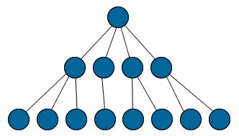  Graph 1: Brute Force

Simple Approach
After finding a Hamilton cycle C, search for another of smaller weight by modifying C.  Let C = v₁v₂…v_{n}v₁, this new cycle C_{ij} could be obtained by deleting edges v_{i}v_{i+1} and v_{j}v_{j+1}  and adding edges v_{i}v_{j} and v_{i+1}v_{j+1} if for some i and j,  w(v_{i}v_{j}) + w(v_{i+1}v_{j+1}) < w(v_{i}v_{i+1}) + w(v_{j}v_{j+1})  As a result, C_{ij} is an improvement on C. | 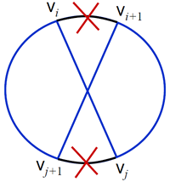  Graph 2: Simple Approach
Nearest Neighbor Method  Starting at vertex v₁, trace (v₁,v₂) which is the shortest edge from v₁. Leave v₂ along (v₂,v₃) the shortest edge from v₂. (Keep the cycle simple.)  Continue until every vertex has been visited. Complete the cycle by edge (v_{n},v₁).  It can be shown that, for this algorithm: $α=\frac{1}{2}\left(\left\lceil \text{ln}n\right\rceil +1\right)$ | 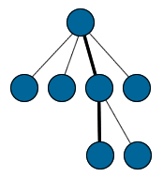  Graph 3: Nearest Neighbor

Twice Around The MST Algorithm
Find a minimum-weight spanning tree T of G. After that, conduct a DFS of T by associating a DFS index L(v) with each vertex  Output the following cycle: C = v_{i1},v_{i2},…,v_{in},v_{i1} where L(v_{ij}) = j . Hamilton cycle visits the vertices in the order of their depth-first indices.  Theorem: The twice-around-the-MST algorithm gives α < 2. | 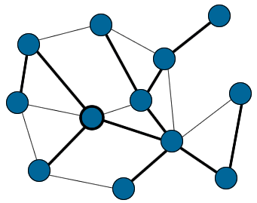  Graph 4: Twice Around the MST

One and Half Around The MST Algorithm
The twice-around-the-MST heuristic can be improved by using perfect matching idea. Therefore, approximation will be α < 3/2 (should be complete graph).  First of all, find a minimum-weight spanning tree T of G. Then, construct the set V’ of vertices of odd deg in T. After that, find a min weight perfect matching M of V’. In the end, construct the Eulerian graph G’ and Hamiltonian graph G’’ by adding the edges of M to T. | 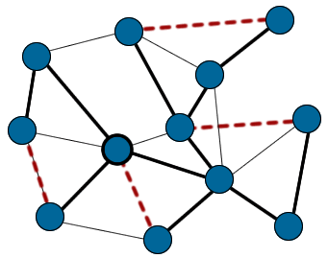  Graph 5: One and Half Around the MST

TSP Simulation Results
We have run the simulation for all five given algorithms in order to compare their running time performances and the success of the algorithms in approximating the minimal costs. For example;
using n = 12 the algorithms wil give,
Brute Force >> t : 1040933µs c : 4188km
Simple Approach >> t : 180µs c : 4188km
Nearest Neighbor >> t : 2µs c : 5310km
Twice Around MST >> t : 35µs c : 4981km
One Half Around MST >> t : 46µs c : 4653km.

Total Costs
The first simulation result is about algorithms success about finding the minimal total costs.
The result is: Brute Force < Simple App. < Nearest Neighbor < 1.5 Around MST < Twice Around MST
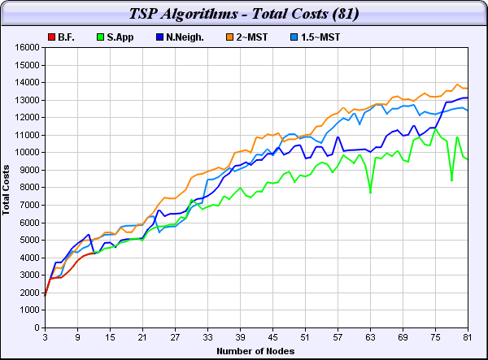
Graph 6: TSP Algorithms - Total Costs

Durations
The second simulation result is about the durations of algorithms, therefore we could analyze the running times of the methods.
The result is: Nearest Neighbor < Twice Around MST << 1.5 Around MST ~ Simple App. << Brute Force
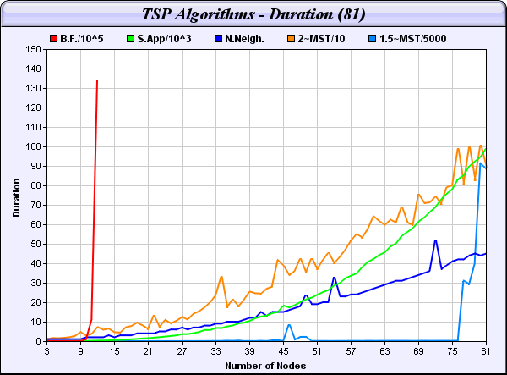
Graph 7: TSP Algorithms - Durations

Face Coloring
Four colors are sufficient to color the regions of a planar map, so that bordering regions are differently colored. (Region: face of a graph embedded in the plane.)
This theorem was one of the best known unsolved problems, until 1976.
We use DFS (depth first search), BFS (breadth first search) and BGB (BFS with Go-Back When Fails) algorithms in order to search the graph.

Search Algorithms
Depth-first search (DFS) is an algorithm for traversing or searching a tree, tree structure, or graph. One starts at the root (selecting some node as the root in the graph case) and explores as far as possible along each branch before backtracking.
In graph theory, breadth-first search (BFS) is a graph search algorithm that begins at the root node and explores all the neighboring nodes. Then for each of those nearest nodes, it explores their unexplored neighbor nodes, and so on, until it finds the goal.
BFS with Go-Back When Fails algorithm runs like BFS with one exception, whenever it fails to color the graph with four colors, it turns back to its mother vertices.

Simulation
A snap-shot of the simulation is given in graph 8. The BGB algorithm colors the map of Türkiye with only 4 colors.
However, the DFS algorithm has to use fifth color three times and the BFS algorithm uses the forth color once.
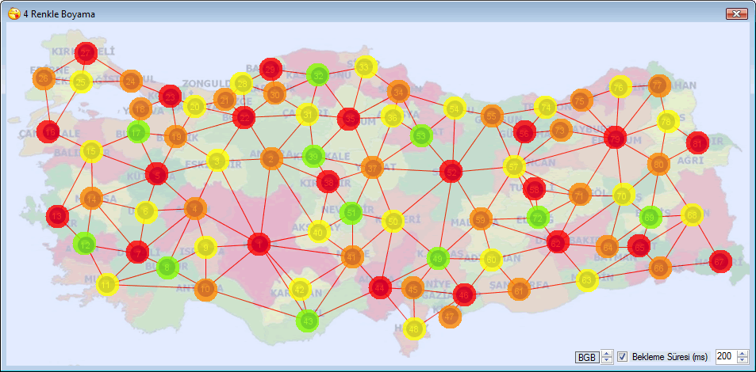
Graph 8: Face Coloring - BGB

Results
This works shows that the optimal solution ordering is Brute Force < Simple App. < Nearest Neighbor < 1.5 Around MST < Twice Around MST. In addition to that, duration ordering is Nearest Neighbor < Twice Around MST << 1.5 Around MST ~ Simple App. << Brute Force.
As a result, I choose nearest neighbor algorithm as the best one. Because, it is the fastest one. And also, has the second best optimal solution exluding brute force. On the other hand, simple approach has the best solution according to others; however, the running time is too much.
In the second work, I have tried to 4-color the Türkiye map as a face coloring graph theory problem. Despite it being difficult to be proven, it is easy to implement face coloring algorithms. After all, worst case performance approximates to 4^{n} which shows that we have a NP-complete problem.

