ANALYSIS OF ALGORITHMS

Homework

Name:  Number:  Date:  Teacher: | Beycan Kahraman  040020337  12.05.2006  Ph. D. Ayşegül Gençata

PROBLEM:

A graph is planar if it can be drawn on a sheet of paper so that none of the edges cross. We will find an effective algorithm to find if a given graph is planar or not?

PURPOSE:

We have to solve this question with using depth-first search. In order to perform this request I have searched some known formulas about understanding if a graph is planar or not. First equation for planar graph is,

e ≤ 3n – 6 where e is number of edges and n is number of nodes.

The theorem concludes that if a graph is planar then the equation holds. However, it could not help us to solve our problem. Since K_{3,3} holds the equation the graph is not planar.

We need a method which guarantees us that the graph is planar. In the end, we could find Euler’s Formula about graphs:

v − e + f = 2 where e is number of edges and v is number of nodes and f is the number of faces.

If the equation that is given above holds, then the connected graph must be planar. We could use this formula to solve the problem with Depth-First Search.
( Reference : http://en.wikipedia.org/wiki/Planar_graph )

SOLUTION:

After finding Euler’s Formula, we have come up with using Depth-First Search algorithm to solve the problem. It is a fact that, we could easily find number of nodes and number of edges by using Depth-First Search algorithm. However, it will be more difficult to find the number of faces in the given graph.

After running well-known Depth-First Search algorithm, we are going to be sure that there are not any cycles in searched graph. So, we have to add some extra lines to this algorithm to find the number of faces. Nonetheless, at first we have to calculate the number of edges and nodes in the graph. Depth First Search is given as this:

dfs(v)
process(v)
mark v as visited
for all vertices i adjacent to v not visited
dfs(i)

( Resource : http://en.wikipedia.org/wiki/Depth-first_search )

We have to change the algorithm to count the number of nodes and edges like this.

newDFS(v, &NumOfEdges, &NumOfNodes, EdgeList)
process(v)
mark v as visited
NumOfNodes ← NumOfNodes + 1
for all vertices i adjacent to v not visited
NumOfEdges ← NumOfEdges + 1
EdgeList.Add(v,i)
newDFS (i, NumOfEdges, NumOfNodes)
end for
end newDFS

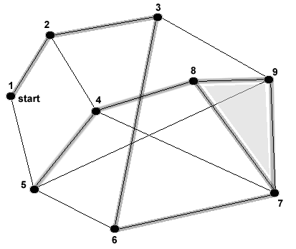  Graph A | After adding the bold values to the algorithm NumOfNodes is the last and correct solution for number of nudes, because we should have find all the nodes in any connected graph with this algorithm.  On the other hand, we have some lack edges that we have not counted yet, which will create cycles in the graph. (NumOfEdges = NumOfNodes – 1 )  That’s the perfect point for us, because any edge added to graph will increase the number of faces in the graph. So we could easily calculate the lack
values with the given LackValues function that will run after newDFS function. Alltogether, when we add k lack edge, we seem to add one exact face for each . Then, with knowing the initial value of NumOfFaces to be 1, we could say that the result is always 2.

v – e + f = v – (v-1) +(1) after first function
= v – (v-1 + k) + (1+k) after second function

However, the thing we will control in the LackValues is, “After adding one of the lack edge, how many new cycles will created”. If there will be two faces added by one edge add, then the graph is not planar.

LackValues(&NumOfEdges, &NumOfFaces, EdgeList)
for all edges i in the graph that are not added to EdgeList
NumOfEdges ← NumOfEdges + 1
tmp = How Many New Cycles Will Be Created
NumOfFaces ← NumOfFaces + tmp
end for
end LackValues

In the end after calling the functions in the given order and control the if statement we could be sure about if the given graph is planar or not.

NumOfEdges ← 0
NumOfNodes ← 0
NumOfFaces ← 1

newDFS(start, NumOfEdges, NumOfNodes, EdgeList)

LackValues(NumOfEdges, NumOfFaces, EdgeList)

if (NumOfNodes – NumOfEdges + NumOfFaces = 2 )
Print “The given Graph is PLanar”;
Else
Print “The given Graph is not Planar”;

When we examine the given two functions to decide about the graph’s planar state, the solution algorithm needs the graph with its edges and nodes as input. In addition, we have give the functions 3 integer values to calculate the number of edges, nodes and faces. Lastly, we have to tick the used edges after run the first function, so that we could use these in finding not used edges in second function. After run these two functions we could decide if the graph is planar or not.
Let’s test the given graph A with these two functions. After we have run the first algorithm,
it will count the number of nodes as 9. Besides this, the function calculates the number of edges as 8, which is 1 smaller than number of nodes.

After running the second function it will increase the number of edges to 14, and the function will calculate the number of faces as 7 for this example.
Then we could easily say that : v − e + f = 9 – 14 + 7 = 2 which means that the given graph is planar (or is not includes K₅ and K_{3,3}).
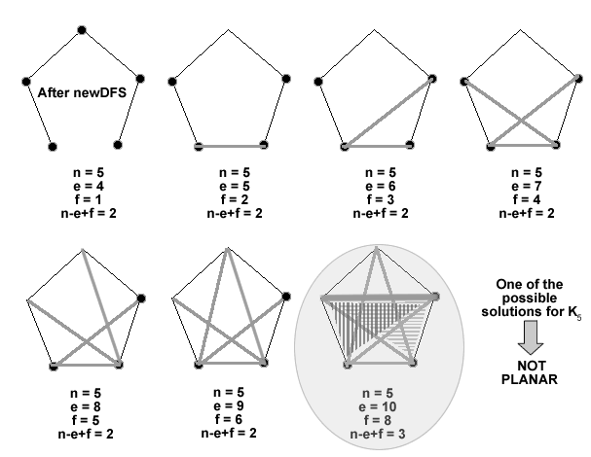

CONCLUSION:

When we run the two functions, we could easily see that the second function works more slowly, because calculating the
tmp = How Many New Cycles Will Be Created
line in the for loop has much work to calculate. Even though, it seems difficult to calculate newly created cycles it gives us the solution. So that, it could be used to reach the planarness of a given graph.

